**Coding Challenge - 1**

**Name:** V Venkata Sri Prasad

**Batch:** Data Engineering

**Question:**

Create Azure DevOps Environment and configuring Azure DevOps Git Repository ,configure on your local git to implement this upload few test files on same.

**DevOps:**

DevOps is like teamwork for software. It's about getting developers and operations folks to work together smoothly, making sure that the software gets built, tested, and delivered quickly and reliably.

In DevOps there are main five features

* **Repos:**

Repos are like organized folders where we keep our code. They help teams work together on writing and updating software without stepping on each other's toes.

* **Boards:**

Boards are like digital sticky notes where we plan our work. They help teams see what needs to be done, who's working on what, and how everything is progressing.

* **Pipelines:**

Pipelines are like automated assembly lines for software. They help us build, test, and deploy our code automatically, so we can deliver changes to our users faster and with fewer mistakes.

* **Test Plans:**

Test Plans are like checklists for making sure our software works as expected. They help us test our code thoroughly, find and fix bugs early, and make sure our users have a smooth experience.

* **Artifacts:**

Artifacts are like carefully labeled boxes where we store our software parts. They help us keep track of different versions of our code, share pieces of code with other teams, and make sure everything is in the right place when we need it.

Now we are going to create a DevOps Git Repository and configure on your local git to implement this upload few test files

Open Azure DevOps Organisation and click on My Azure DevOps Organizations.

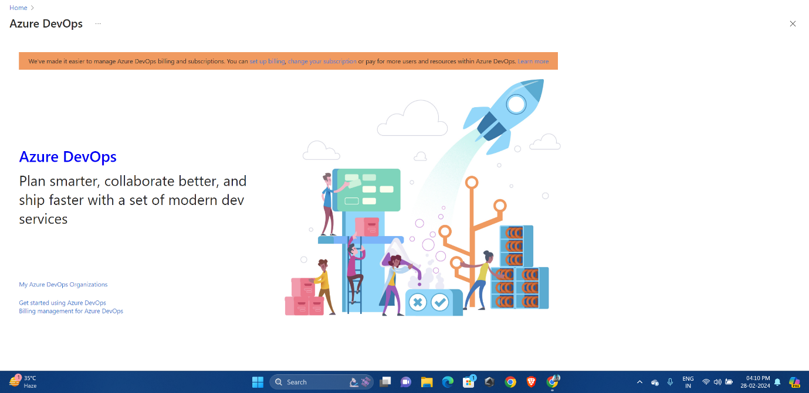

Click on Create new project and provide the proper name and authentication.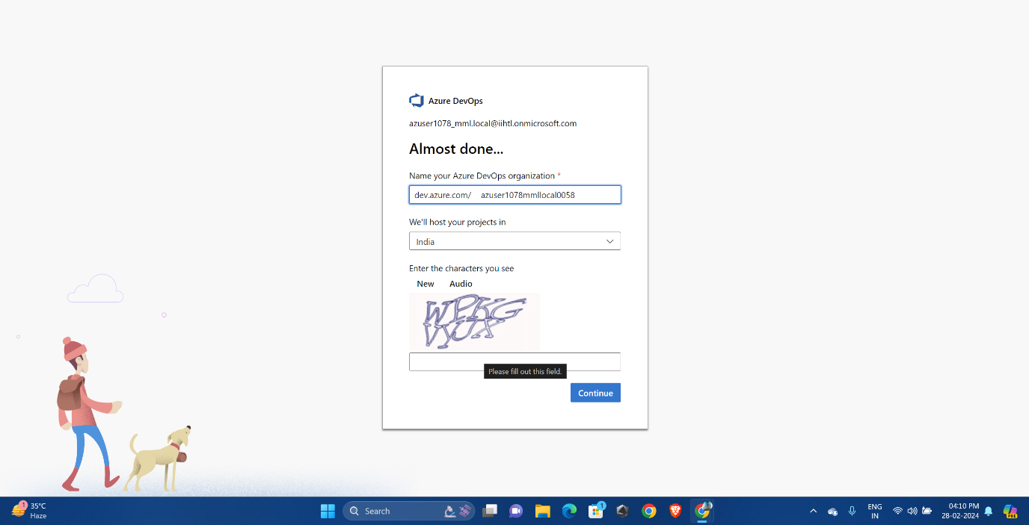

Provide the Project name and select private project and click on create.

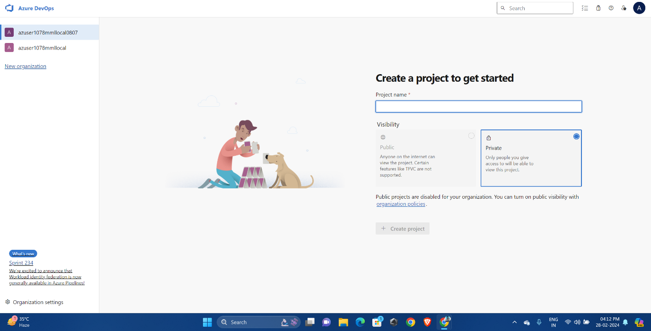

Click on files and create a new repository. 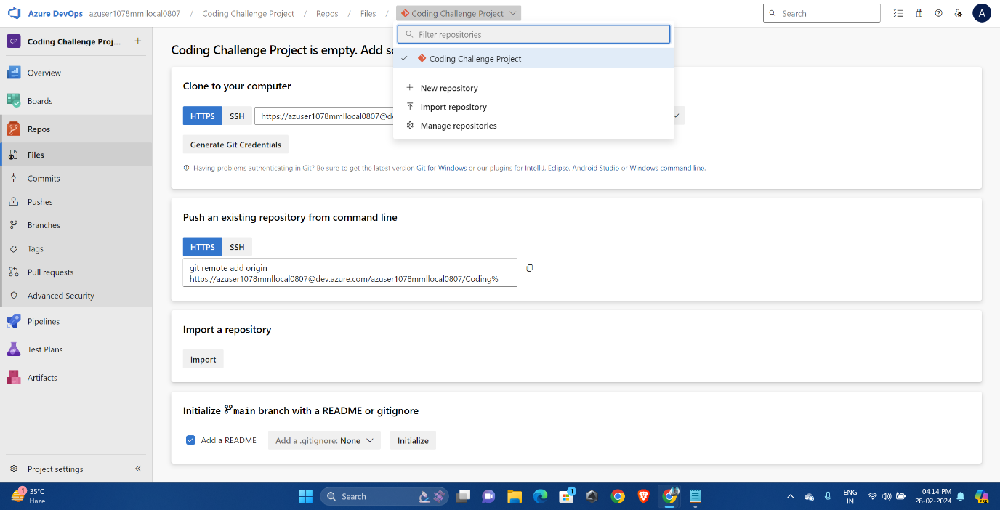

Copy the clone link. 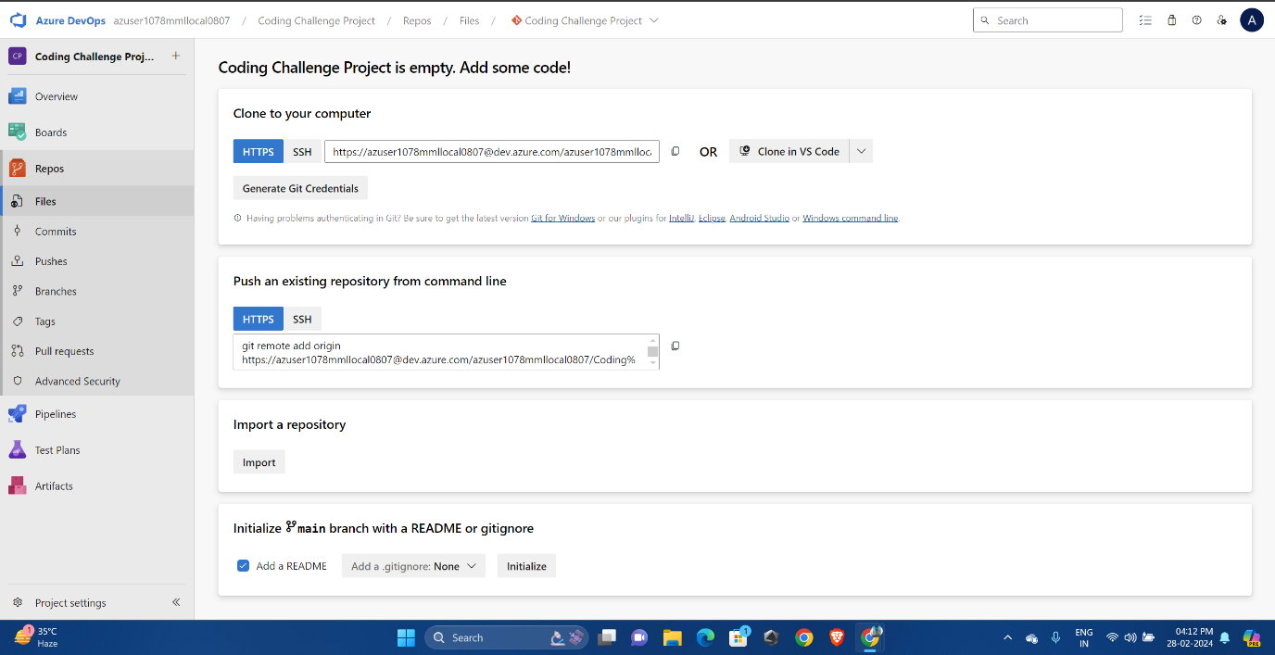

Go to git bash and follow the instructions as shown in the picture.

* cd downloads
* cd AzureCodingChallenge
* git clone https://azuser1078mmllocal0807@dev.azure.com/azuser1078mmllocal0807/Coding%20Challenge%20Project/_git/CodingChallengeRepository
* ls
* cd CodingChallengeRepository
* ls
* touch file
* git add file
* git commit -m "This is coding Challenge file"
* 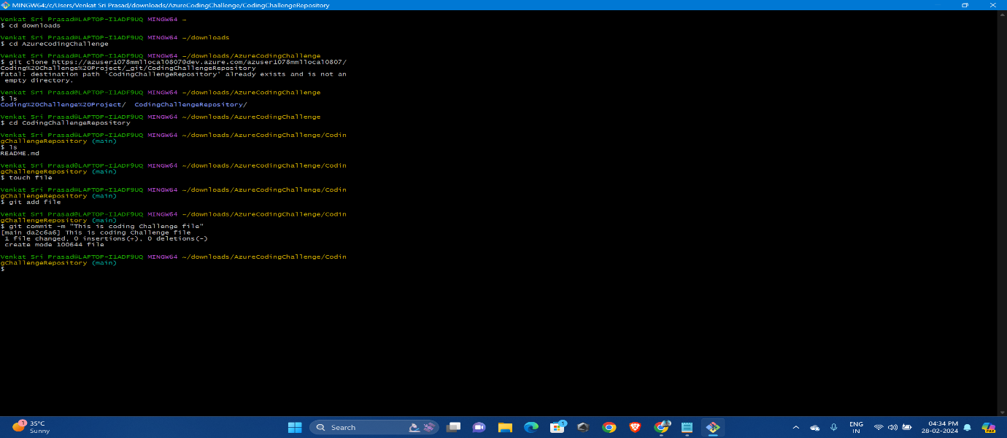

Now we can see here the file which we have created in the git bash has been created in azure repos.

* 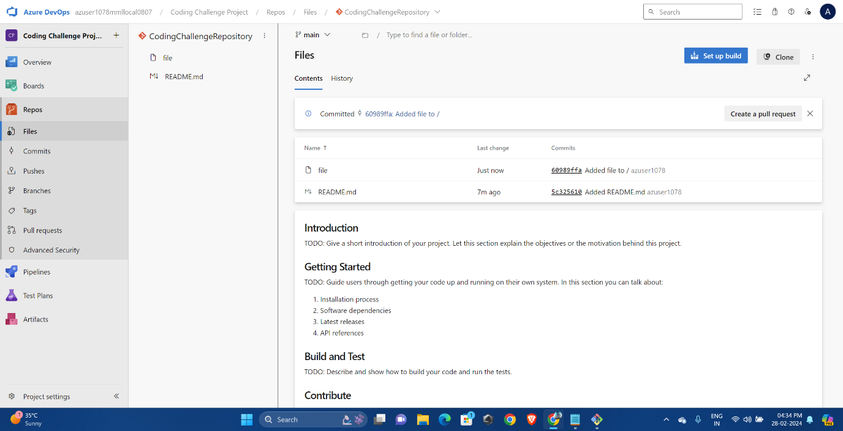

The file will be created in the local storage also.

* 